**LOGO DESIGN**

1. **STAGES**

**Sketches, drafts**

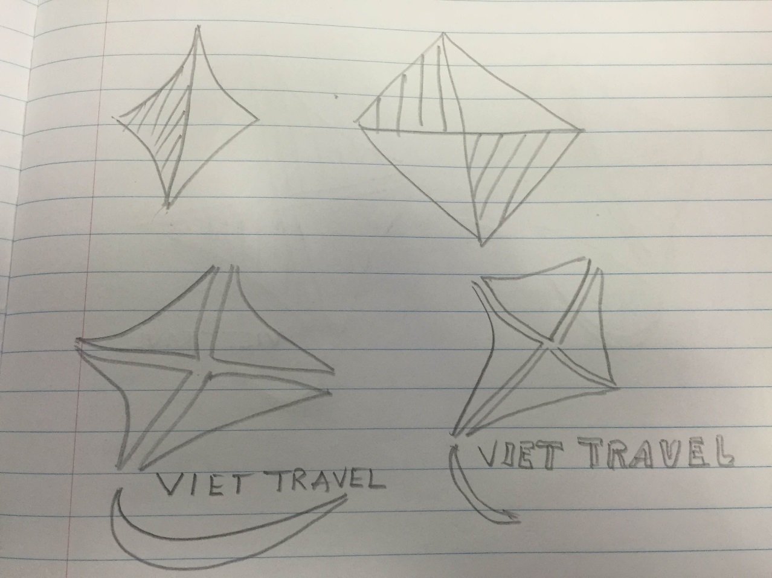

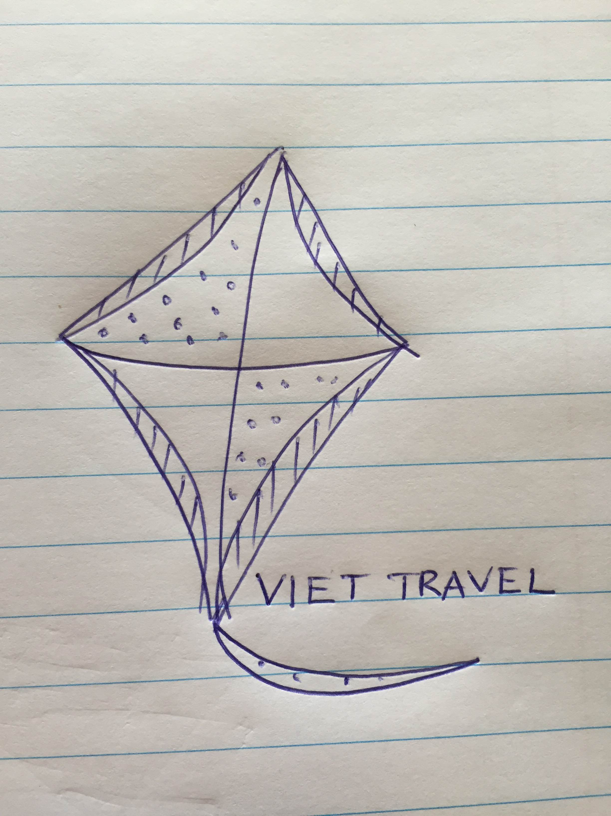

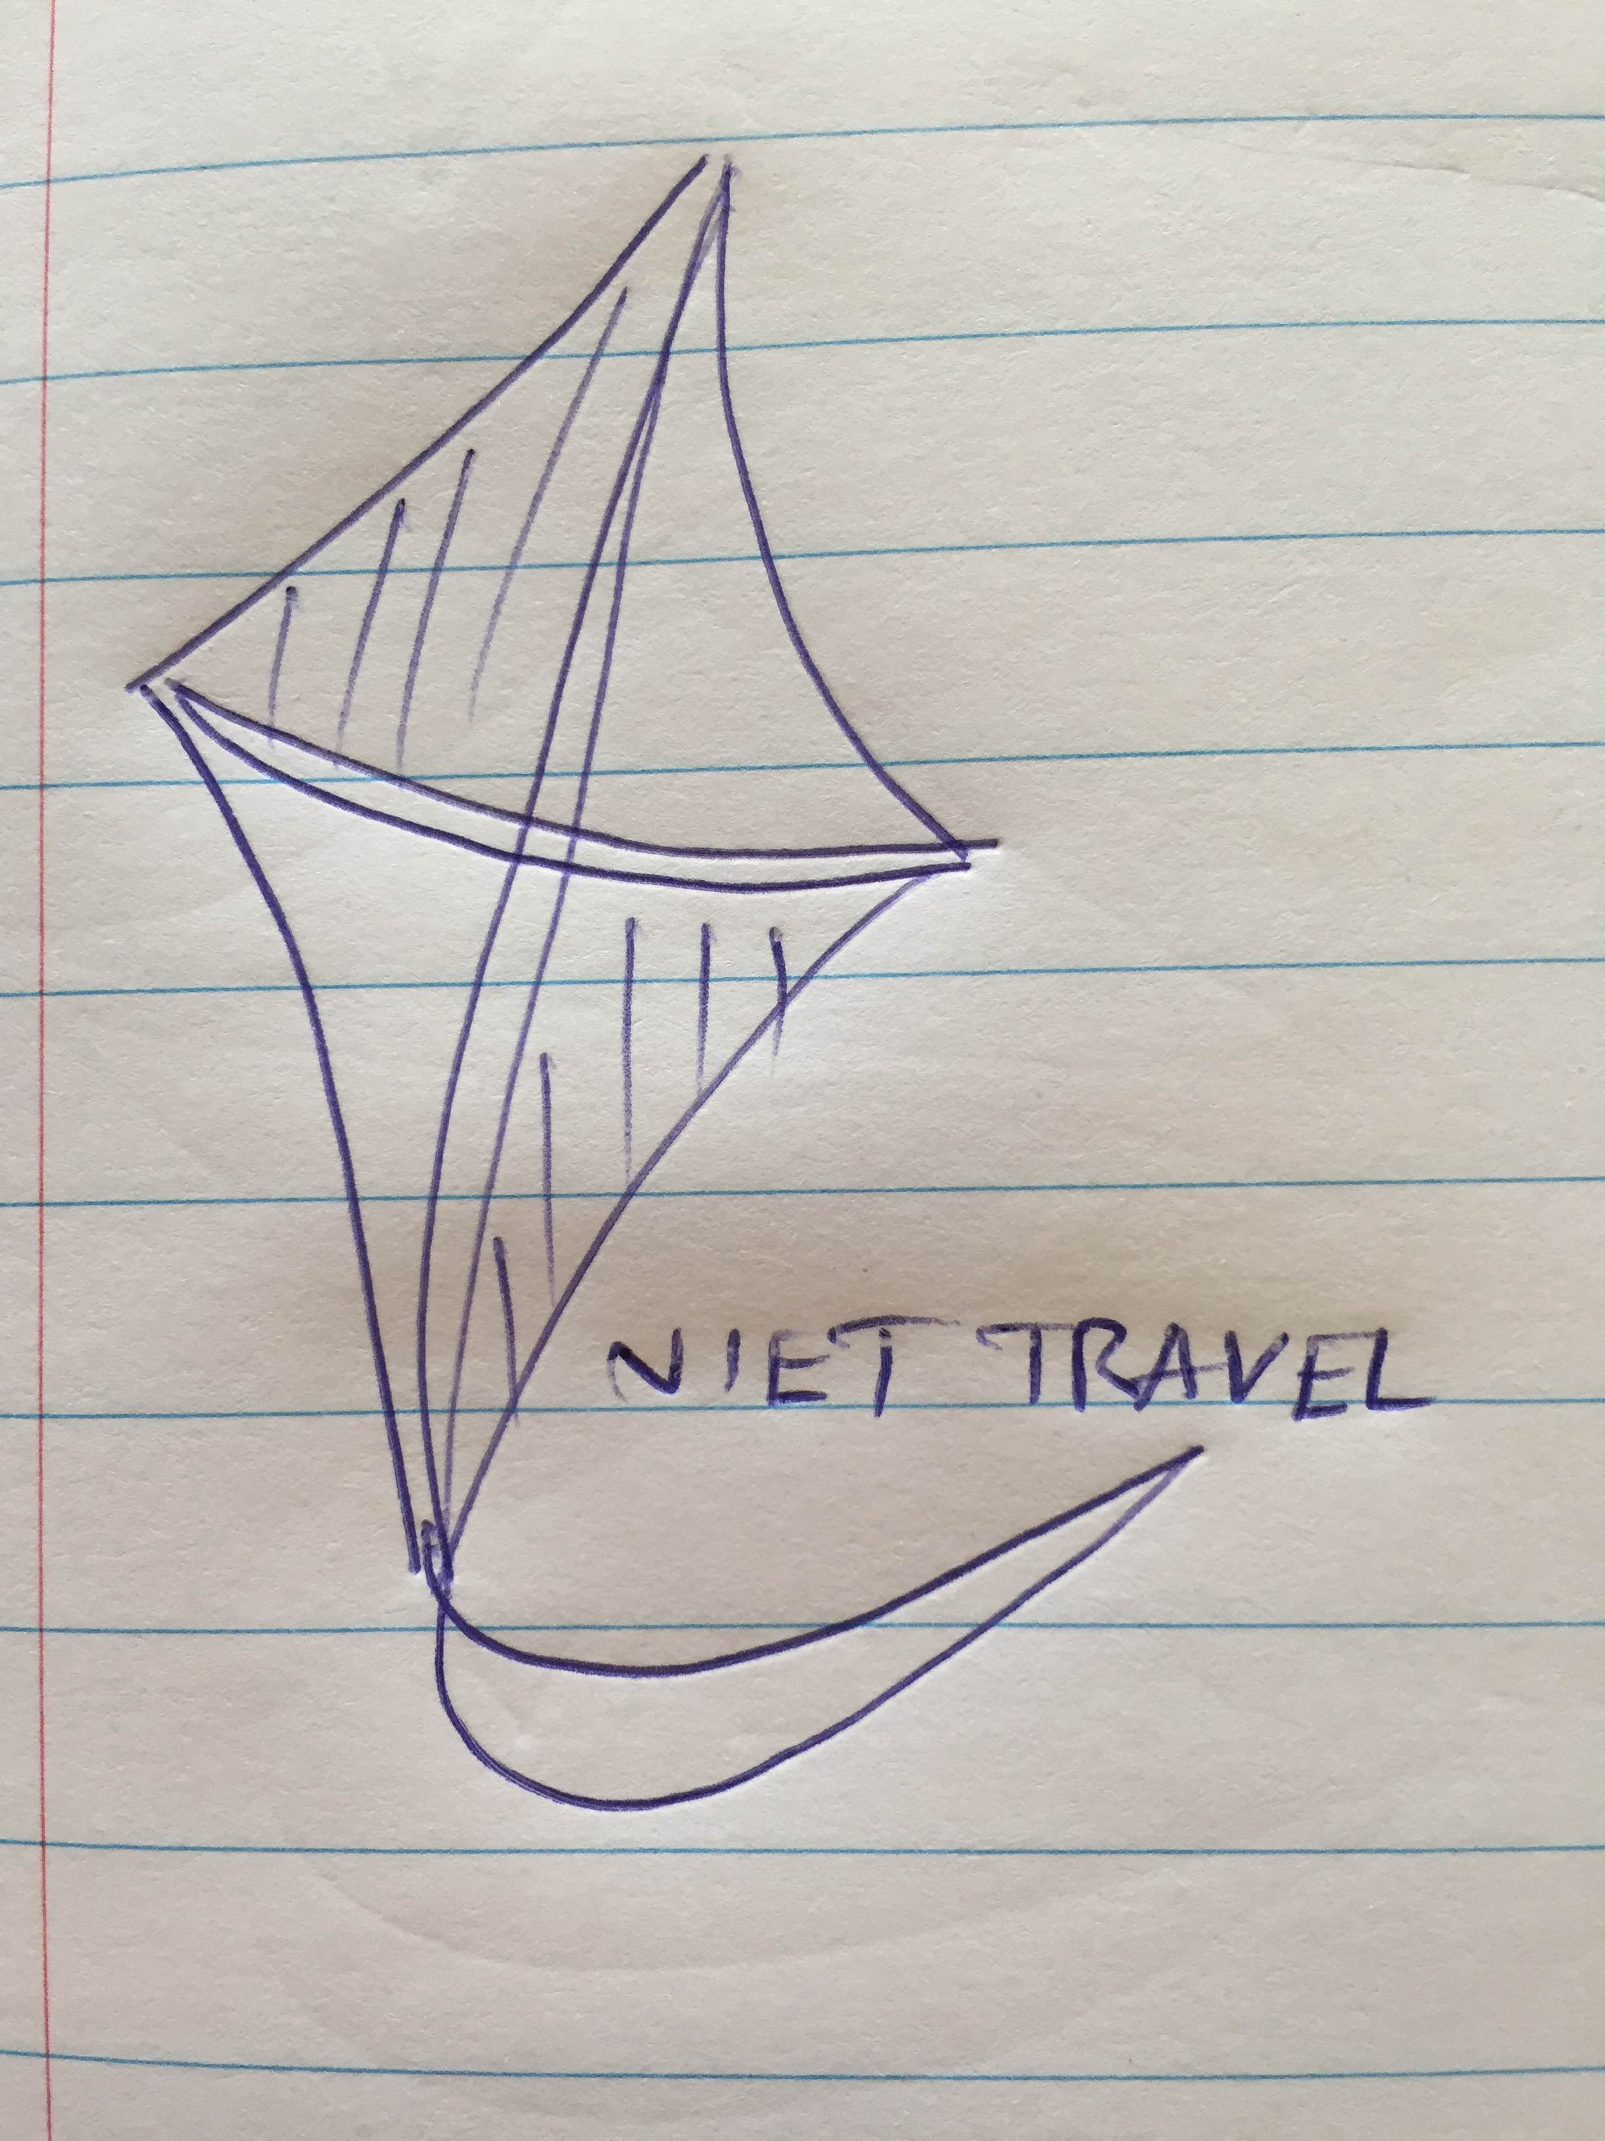

Designs

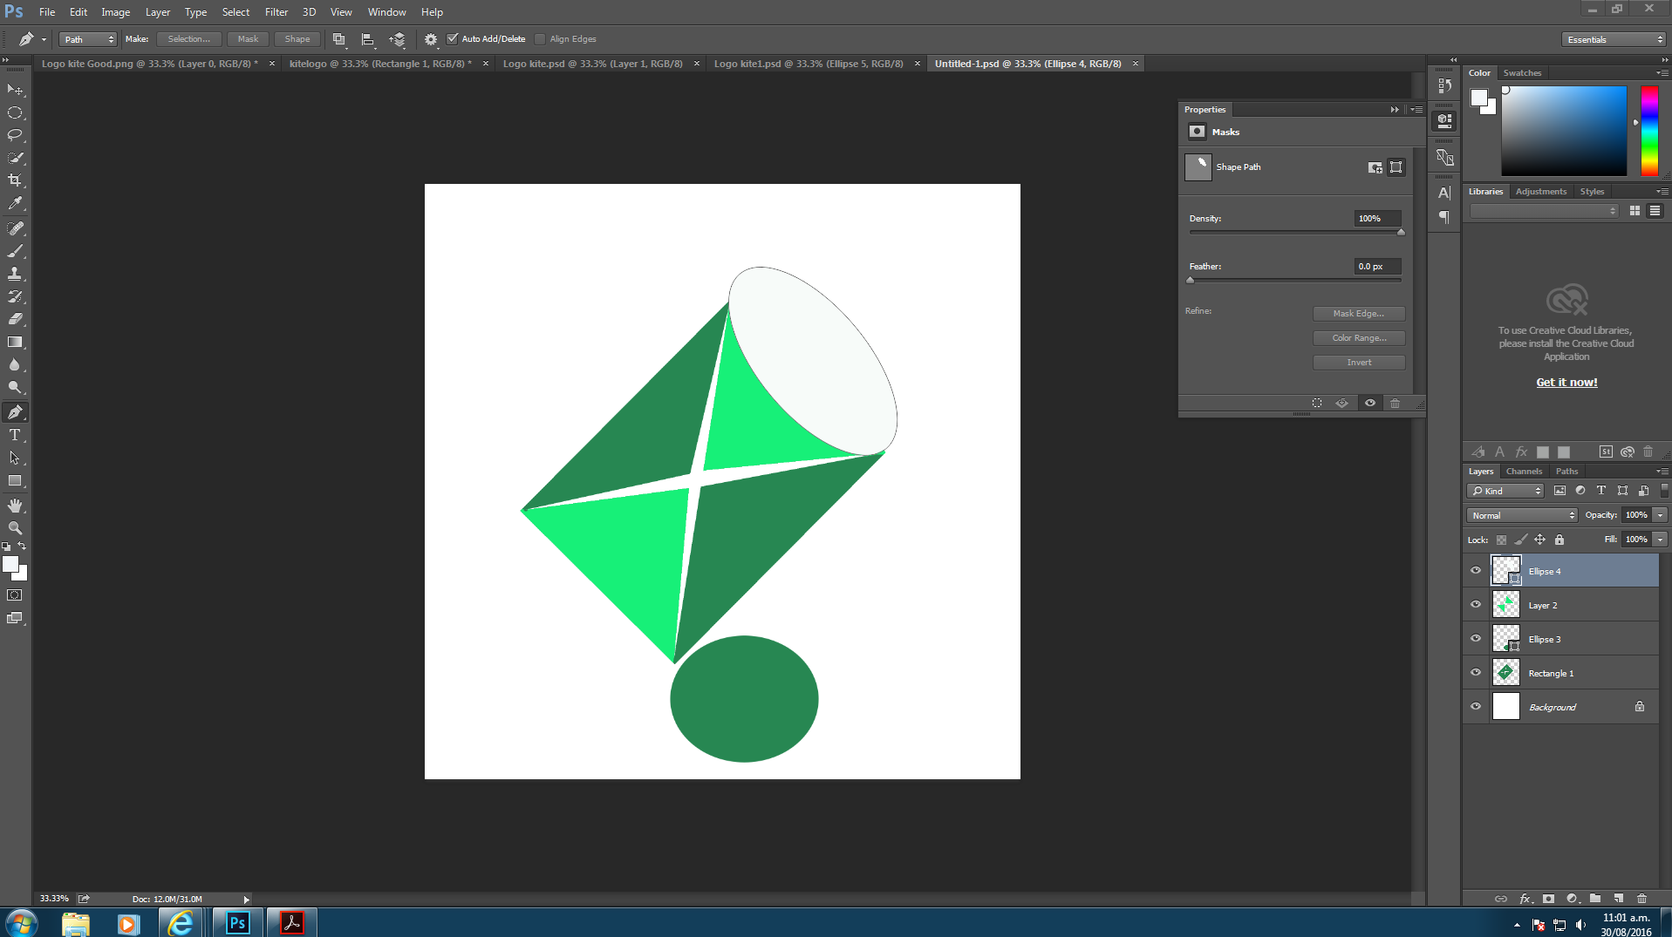

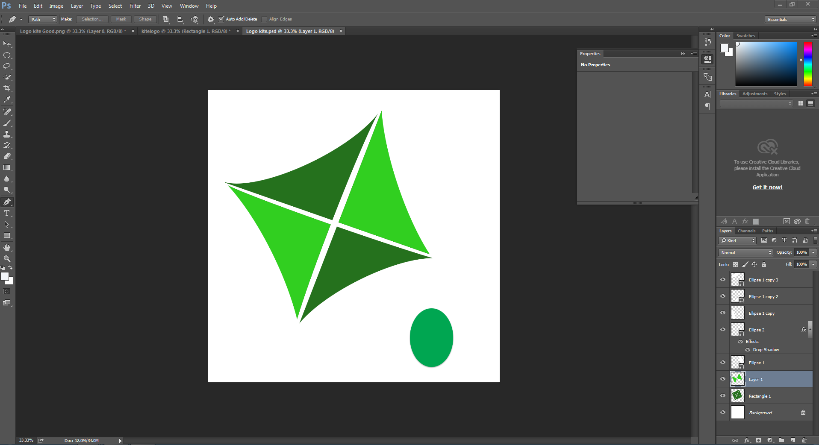

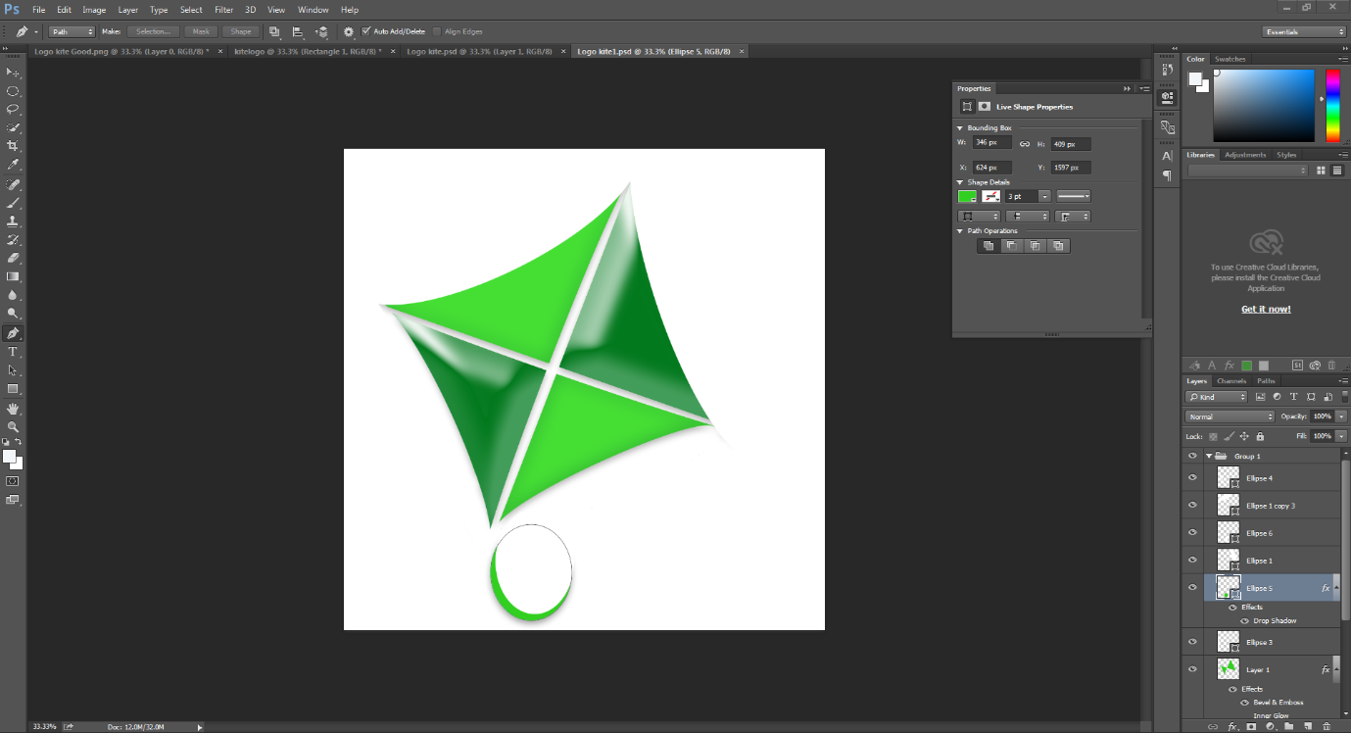

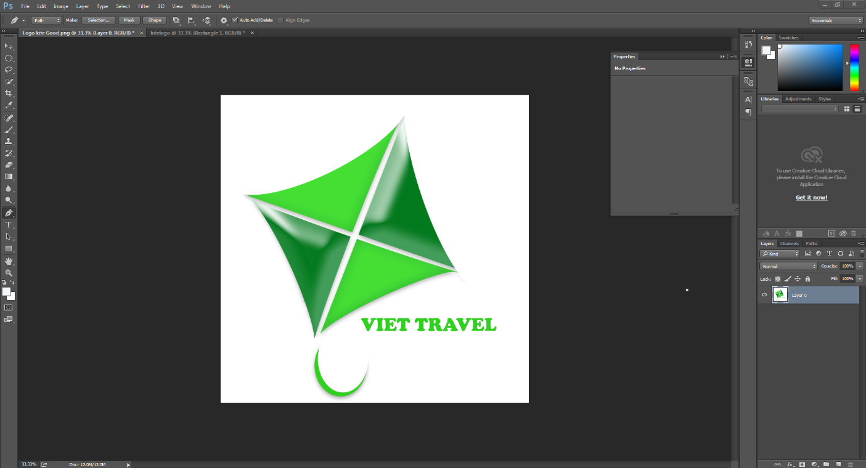

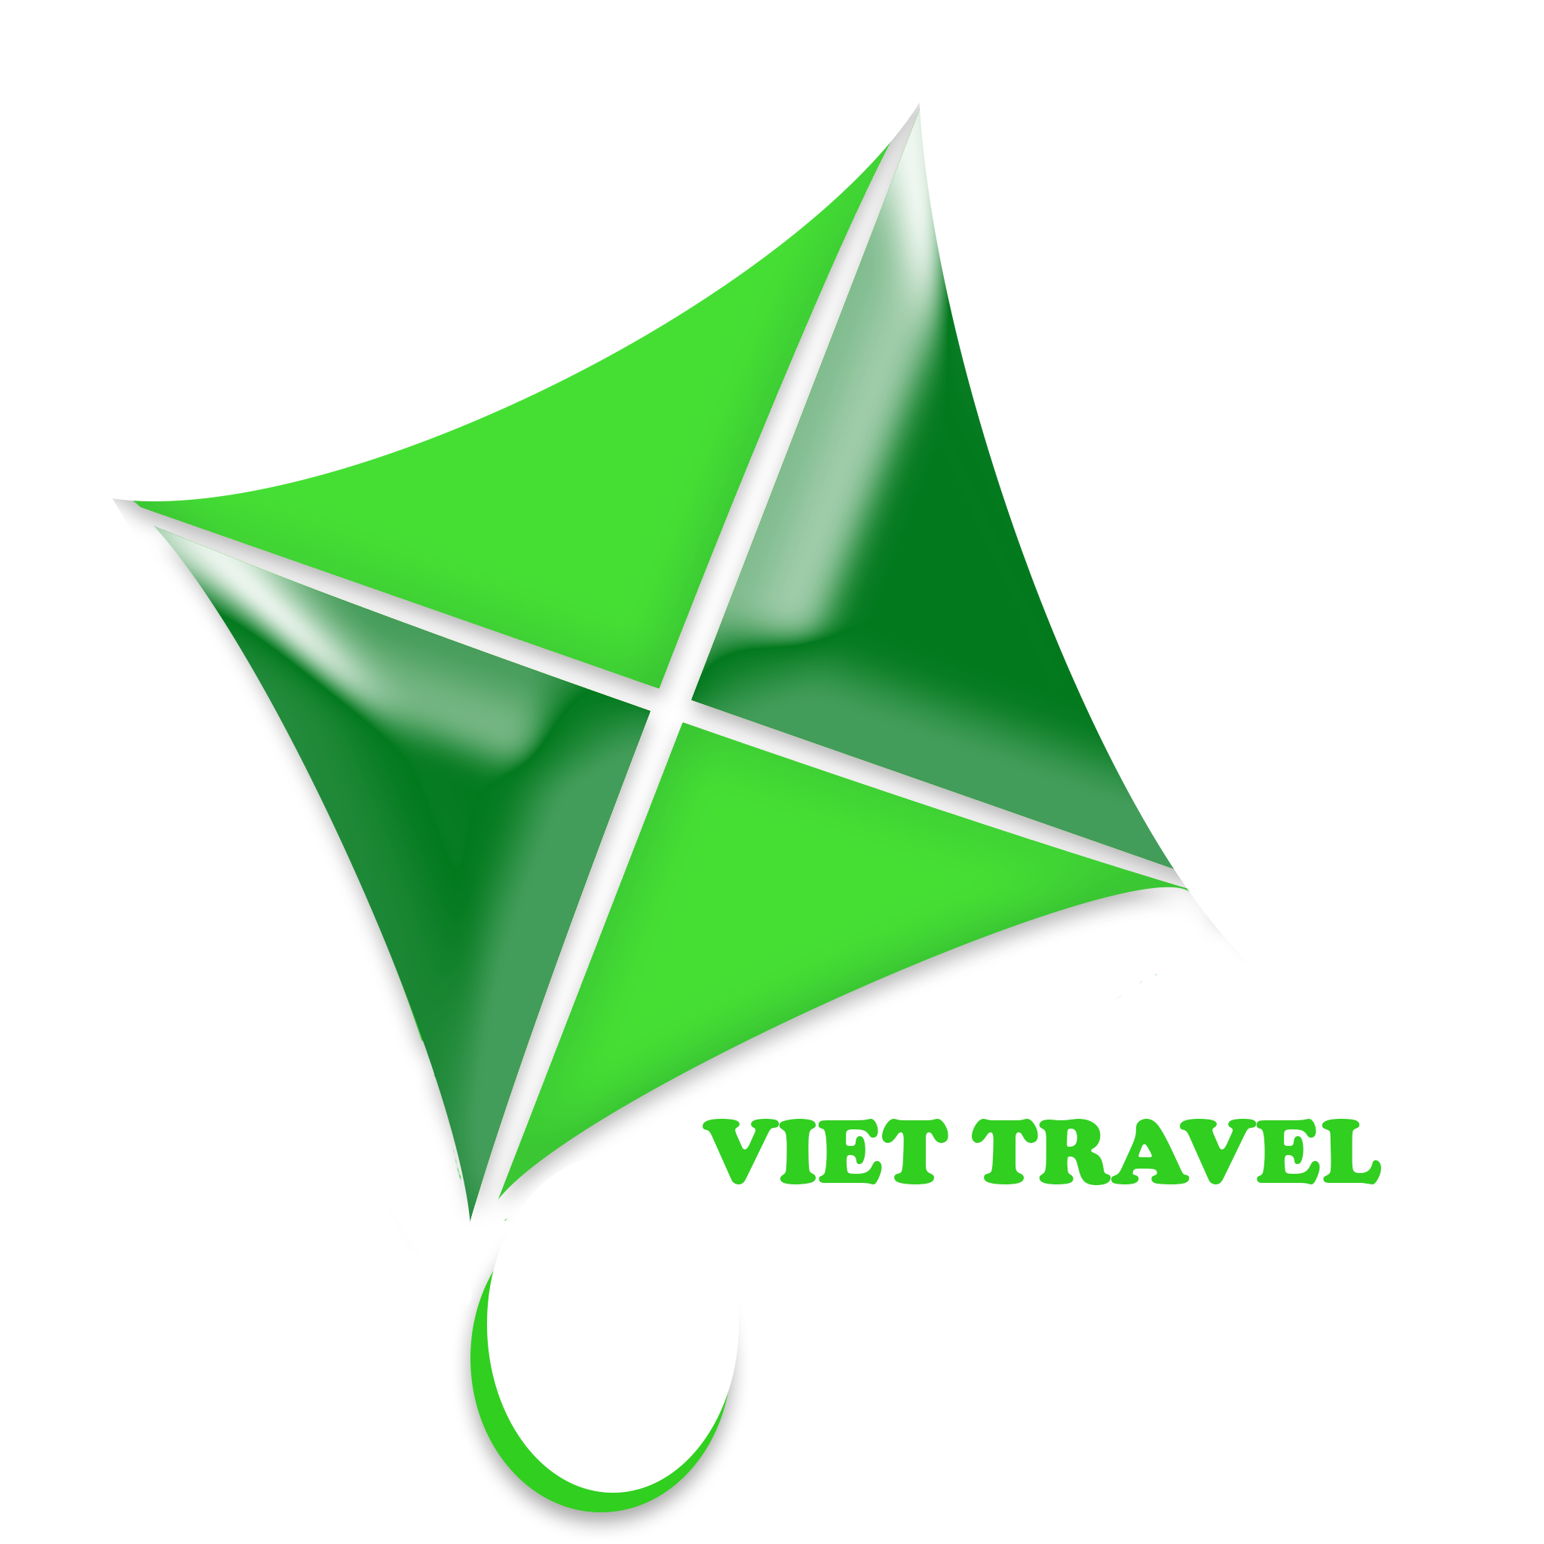

1. Introduction company

Vietnam is in the process of global integration and international cooperation. This connection is expressed through many aspects of life with the achievements and results of the economy in recent years.

The integration process is not only to promote economic development beyond levels that go along with the increasing demands on quality and superior customer service. Foreseeing this demand with the introduction VIET TRAVEL will” always bring joy and satisfaction to guests needs”.

VIET TRAVEL has not operated yet, but in the future, VIET TRAVEL will make a big change to provide full of services and tourism events in domestic and international countries with professional, accurate, affordable and expert team.

VIET TRAVEL will expand the number of foreigners on the globe knowing Vietnamese culture and tourism, as well as Vietnamese people will get more knowledge the world surroundings.

1. Explanation logo

From hustle and bustle of daily life, people would like to change and discover to new thing and attractive lands, so they will make a trip to somewhere in domestic or around the world where bring to them satisfaction such as eco-holiday, ancient architectures and so on.

Green contains the powerful energies of nature, and growth, is the colour of growth, the colour of spring. Renewal and rebirth, renewal and recovery of energy has been reduced.

In my opinion, kite seems to be a symbol of freedom and discovery.

Accompany with green color which will be suitable with my ideal logo.